Study of the nuclear shape evolution with the AGATA spectrometer

The general framework of this PhD project is structure of atomic nuclei and, more particularly, the study of the shapes of intermediate mass nuclei (A~70). This project is a part of an extensive experimental program on shape coexistence undertaken by our group. To this aim, we combine multiple complementary experimental techniques: identification of excited states and analysis of their decay using high-resolution gamma-ray spectroscopy, direct lifetime measurements of the excited states and, finally, Coulomb excitation, which provides information on the charge distribution (i.e. the shape) of the studied nuclei. The experimental information on the properties of excited states obtained from the combination of the various measurements is then confronted with the results of state-of-the-art theoretical models of nuclear structure, providing their detailed tests.
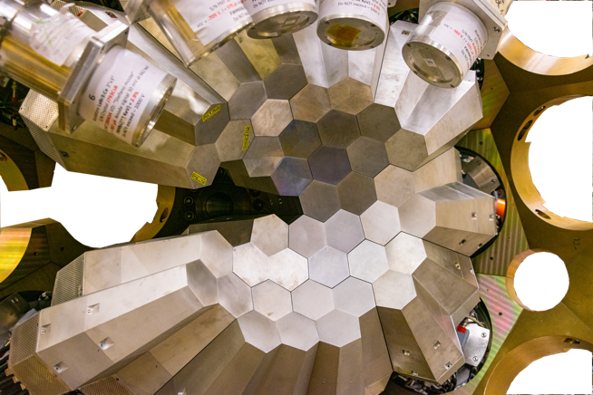
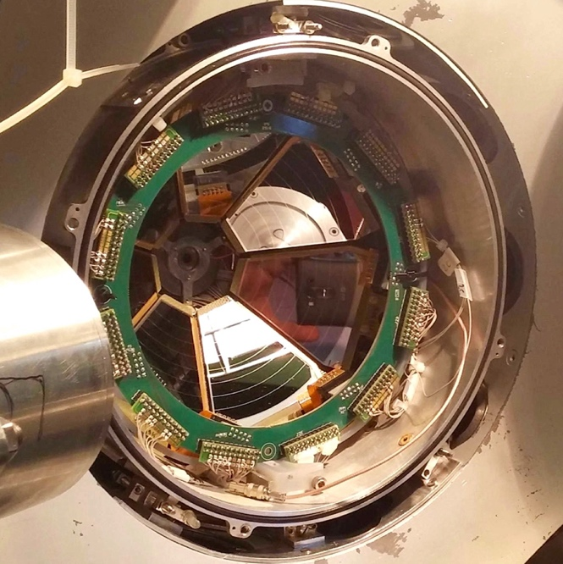

Germanium detectors of the Advanced Gamma Tracking Array, AGATA, (top) and the SPIDER Si detector array (bottom) will be used in the Coulomb excitation experiment, to detect γ rays and scattered particles, respectively.

The shape of a nucleus, i.e. the deviation of its mass and charge distribution from sphericity, is one of the fundamental nuclear properties. It is governed by both macroscopic effects (the nucleus behaves like a liquid drop) and microscopic effects, such as the shell structure of the nucleus. Their competition may lead to rapid changes in the shape of nuclei as a function of the number of nucleons.

While nuclei with closed proton and neutron shells are always spherical, those away from the closed shells will deform to minimise their potential energy, and most often assume an elongated ellipsoidal shape. The light isotopes of krypton and selenium are a key region in the study of deformation. Some of these nuclei exhibit a rare phenomenon of shape coexistence [1,2]: the nucleus changes its shape radically at low excitation energy. Moreover, this is one of the few regions in the nuclear chart where nuclei are predicted to assume oblate (flattened) shapes in the ground state.

The thesis will focus on the experimental study of the nuclear properties of the lightest stable selenium isotope (⁷⁴Se) using the powerful Coulomb-excitation technique [3], which is the most direct method to determine the shapes of nuclei in their excited states. In this process of nearly elastic scattering of two nuclei, the electromagnetic field acting between them causes their excitation. The nuclei then immediately de-excite, emitting photons that are measured with gamma-ray spectrometers surrounding the target.

If the distance of closest approach between the projectile and target during the scattering process is sufficiently large, the short-range nuclear interaction can be neglected and the excitation can be described using the electromagnetic interaction, the properties of which are well known. Consequently, the population cross sections of the excited states measured in Coulomb-excitation experiments can be directly related to the static and dynamic moments of the charge distribution (i.e. the shape) of the nuclei under study.

We performed a Coulomb-excitation experimeny to study ⁷⁴Se using AGATA [4,5], a new-generation gamma-ray spectrometer, consisting of a large number of finely segmented germanium crystals, which allows us to identify each point where a gamma ray interacts with the detector material and then, using the so-called “gamma-ray tracking” concept, to reconstruct the energies of all emitted gamma rays and their angles of emission with highest precision. This powerful spectrometer, offering unprecedented detection efficiency and experimental sensitivity, was developed by a large collaboration of researchers from 13 European countries and is currently installed at the National Laboratories of Legnaro (LNL, Italy) where the experiment on ⁷⁴Se took place.

We observed population of multiple excited states in ⁷⁴Se, including some for which the previous experimental information is very limited. For this reason, we are planning a complementary particle-transfer measurement to investigate properties of low-lying states in ⁷⁴Se.

The student will be in charge of the analysis of the data from the AGATA experiment, as well as preparation and analysis of data from the future particle-transfer study. During the PhD thesis the student will also have the possibility to participate in other experiments of the group at various accelerator facilities (LNL Legnaro, CERN-ISOLDE, TRIUMF etc.) and to present their results at collaboration meetings and conferences. An involvement in the tests and repairs of complex HPGe detectors, being performed at our dedicated AGATA detector laboratory at Saclay, can also be envisaged. A more extensive theoretical work may also be considered in collaboration with theorists at CEA/DAM depending on the interests of the candidate.

Bibliography
[1] K. Heyde and J. L. Wood, Rev. Mod. Phys. 83, 1467 (2011)
https://doi.org/10.1103/RevModPhys.83.1467
[2] P. Garrett, M. Zielińska and E. Clement, Prog. Part. Nucl. Phys. 124, 103931 (2022)
https://doi.org/10.1016/j.ppnp.2021.103931
[3] M. Zielińska et al., Eur. Phys. J. A 52, 99 (2016) https://doi.org/10.1140/epja/i2016-16099-8
[4] S. Akkoyun et al., Nucl. Instrum. Meth. Phys. Res. A 668, 26 (2012) https://doi.org/10.1016/j.nima.2011.11.081
[5] W. Korten et al., Eur. Phys. J. A 56, 137 (2020) https://doi.org/10.1140/epja/s10050-020-00132-w

Environnement de travail / Working environment
The student will be working in IRFU/DPhN/LENA, a group of about 20 researchers, post-docs and PhD students. We perform research on several aspects of nuclear structure physics, such as the evolution of the nuclear shell structure, nuclear shapes and the properties of the heaviest elements. We also develop innovative detection systems with a support from IRFU technical divisions. In particular, the group has a vast expertise in measuring electromagnetic properties of atomic nuclei. The student will thus be working in a very fruitful environment combining expertise on different detection techniques (gas, scintillation and semiconductor detectors) and analysis methods (Coulomb excitation, Doppler-shift and fast timing techniques, etc).

The PhD supervisors are internationally renowned experts in nuclear-structure physics and in particular the Coulomb-excitation technique. They have been the spokespersons of many projects at different international accelerator facilities, e.g. HIE-ISOLDE (CERN), LNL (Italy), TRIUMF (Canada), etc., and as such will give the PhD candidate a chance to participate in other experiments and to acquire a broader knowledge of nuclear structure physics.

Collaborations
The student will be a part of a medium-sized international collaboration within the more extensive community gathered around the AGATA project. The interpretation of the obtained results will build on the existing fruitful collaboration with theorists from CEA/DAM (Bruyeres-le-Chatel) and Spain (University of Madrid).

Training and required skills
We are looking for candidates with a strong interest in nuclear physics, who enjoy experimental work and are not afraid of complex detection systems. A dedicated nuclear physics course on the master level as well as an internship or master thesis in the domain of experimental nuclear physics are strongly recommended. Some prior knowledge of computer programming (C, C++, root) is also recommended, as well as at least a B2 level in English.

Contacts

Magda Zielińska: magda.zielinska@cea.fr
Wolfram Korten: wolfram.korten@cea.fr

